

CHAIR MANUFACTURING BI
Business Intelligence Portfolio Case Study
Portfolio project based on a fictional medium sized U.S. manufacturer
Excel / Power Query | Python | SQL / SQLite | Power BI / DAX

Project Overview
With this project, I wanted to work through a realistic BI problem from start to finish. I started with raw CRM and ERP style exports, cleaned and validated the data, analyzed it in SQL, and built the final reporting in Power BI. I also wanted to be able to explain where the major numbers came from and why they were calculated that way.
51,038  Cleaned rows | 7  Core source tables | $310.32M  Won sales | $283.73M  Shipped revenue
$33.24M  Open pipeline | $15.13M  Current backlog | 46.27%  Shipped margin | 91.93%  On-time rate

The data covers roughly September 2021 through September 2026. It includes CRM and ERP style activity across accounts, opportunities, orders, order lines, returns, warranty claims, and product reference data.

Business Problem
Northline Seating is a fictional medium sized U.S. chair manufacturer. Management needs a dependable view of the business from the first sales opportunity through shipment. They also need visibility into margin, backlog, delays, returns, warranty claims, and customer performance.
The reporting questions cross several tables and different levels of detail. Pipeline is at the opportunity level. Financial and shipping activity is at the order line level. Returns and warranty claims can also occur more than once against the same order. I had to make sure those differences were handled correctly before building the report.

Questions I Needed to Answer
- What is in the current sales pipeline, and which opportunities need follow up?
- How much business is being won, shipped, and held in backlog?
- Which sales reps, accounts, products, and product families are performing well?
- Where are margins strong or weak?
- Are orders shipping when promised, and which open orders are currently delayed?
- Why are opportunities being lost or orders being cancelled?
- Are returns and warranty claims showing product or fulfillment patterns?
- Are a small number of accounts driving too much of the business?

Data and Scope
Source | Cleaned Volume
Accounts | 1,247 cleaned account records
Opportunities | 11,500 CRM opportunities
Orders | 6,880 ERP order headers
Order Lines | 29,918 ERP order lines
Returns / RMAs | 850 return records
Warranty | 600 warranty claims
Product Reference | 43 current and legacy product codes plus FREIGHT and TAX

I kept the raw exports unchanged and did the cleanup in separate working copies. This made it easy to compare the cleaned data back to the original source when something looked wrong.

Data Preparation and Cleanup
I did most of the cleanup in Excel and Power Query. I focused on issues that could affect reporting instead of trying to make every unusual record look perfect.
- Standardized formats and data types, including ZIP code handling and date fields.
- Removed exact duplicate extract rows where the duplicate could be confirmed.
- Created and validated stable account and order line keys for relationships between tables.
- Matched opportunity accounts only when I could support the match. I left ambiguous records unresolved instead of guessing.
- Separated product activity from FREIGHT and TAX line codes so product revenue, quantity, and margin were not overstated.
- Built shipped quantity, shipped revenue, backlog quantity, and backlog value using order line status and ship date logic.
- Reconciled order header Value, Freight, Tax, Total, and COGS back to the order lines.
- Kept data quality review flags on records that still needed context instead of deleting them.

Python QA
After cleanup, I ran a pandas QA script against all seven cleaned tables. I used it to catch broken relationships, calculation problems, and reconciliation issues before moving on to SQL and Power BI.
QA Area | Result
Calculation checks | 0 mismatches in margin, total, margin %, shipped revenue, shipped quantity, backlog value, and backlog quantity
Order reconciliation | 0 mismatches in Value, Freight, Tax, Total, and COGS between order headers and order lines
Relationship checks | 0 invalid cleaned relationships across orders, order lines, accounts, products, returns, and warranty
Clean key checks | 0 duplicate cleaned order line keys and 0 missing required order line keys
Visible review items | 78 order lines and 23 orders remained flagged for data quality review
Unresolved CRM mapping | 69 opportunity Account IDs remained unresolved because the correct match could not be established confidently
Lifecycle exception | 26 Won opportunities did not have a matching standard ERP order and were kept visible as an exception

I did not force the remaining exceptions to zero. If the source did not give me enough information to make a reliable correction, I left the issue visible.

SQL Analysis
I loaded the cleaned files into SQLite and ran the data through SQL. This gave me another way to check the cleaned data and answer the main business questions before building the Power BI report.
- Row counts, key uniqueness, null checks, calculation validation, and relationship checks.
- Won sales by year and sales rep.
- Open pipeline and stale opportunities.
- Shipped revenue, backlog, and margin by product and sales rep.
- Lost opportunity reasons and cancellation reasons.
- Returns and warranty reason analysis.
- On-time performance, top accounts, repeat business, and bookings vs. backlog vs. shipments.

Power BI Model
The Power BI model keeps each business process separate. Accounts, Date, Product Reference, and Sales Rep are shared dimensions. Opportunities, Orders, Order Lines, Returns, and Warranty stay at their own level of detail.
Model Area | Purpose
Opportunity fact | Pipeline, stale opportunities, won/lost activity, quote revisions, and sales credit
Order header fact | Order status, payment terms, promised dates, adjusted dates, cancellation, and on-time logic
Order line fact | Product level shipped revenue, quantity, COGS, margin, and backlog
Returns fact | RMA reason, quantity, refund, disposition, product, account, and rep
Warranty fact | Claim reason, resolution, quantity, product, account, rep, and replacement order traceability

I extended the Date table through January 2027 because three open opportunities had projected close dates in January 2027. The report date slicers still stop at the end of 2026, but the model keeps those future opportunities.

Core Reporting Logic
- Won Sales comes from CRM opportunities marked Won.
- Open Pipeline includes only open CRM opportunities and excludes Lost business.
- Shipped Revenue is recognized from product order lines on the line Ship Date.
- Backlog is the remaining unshipped product line Value on open or partially shipped orders.
- Margin uses historical transaction Value and COGS, not current Product Reference cost.
- On-time logic counts company or vendor misses as late even when an adjusted date exists. A payment hold is not counted late when the order was ready on time.
- Current Open Pipeline and Current Backlog are current snapshot measures, so they ignore the Date slicer.

Weighted Account Ranking
Management wanted a way to rank accounts using more than revenue. I built a weighted score using Won Value, margin, Won Orders, Pipeline Value, Return Rate, and Warranty Rate.
Component | Weight
Won Value | 30%
Average Margin % | 20%
Won Orders | 15%
Pipeline Value | 15%
Return Rate | 10% (lower is better)
Warranty Rate | 10% (lower is better)

Each measure is normalized before weighting so a large dollar measure does not control the entire score. Accounts without shipment history get a neutral return and warranty score.

Report Design
The final report has 12 main pages and one hidden Account 360 drillthrough page. I kept the same basic layout and navigation across pages so the report feels consistent.
- Executive Overview
- Sales Pipeline
- Lost Opportunities & Cancelled Orders
- Customer & Rep Performance
- Sales Rep Workspace
- Account Ranking
- Account Concentration & Repeat Business
- Product & Margin
- Bookings vs Backlog vs Shipments
- Backlog & Shipping
- Delays & Operations
- Returns & Warranty
- Account 360 (drillthrough)
The Delays & Operations page changed during the build. I made it a current work queue for open orders with an Adjusted Promised Ship Date. Closed and cancelled orders are not included.

Key Business Findings
Won sales were $73.19M in 2025. Through September 2026, Won sales had already reached $75.38M.
Of the $33.24M in open pipeline, $19.55M was stale. That is 58.8% of current pipeline value, so stale opportunities need regular follow up.
Office Chairs are the largest part of the business. They generated about $184.72M in shipped revenue, or 65.1% of total shipped revenue. They also made up about 74.6% of current backlog.
Overall shipped margin was 46.27%. Office Chairs were about 47.18%, Folding Chairs 44.74%, Yard Chairs 43.96%, and Spare Parts 52.35%.
Competitor Selected and Price made up about 46.8% of lost opportunity value. Those two reasons are the first place I would look when reviewing lost business.
Customer concentration was low. The top 10 accounts represented about 4.4% of shipped revenue. Repeat business was also strong. Of 1,081 accounts with shipped standard orders, 941 had more than one shipped order, or 87.0%.
On-time performance for standard orders was 91.93%. The separate delay page keeps current issues visible without mixing them into historical performance.

Recommendations
- Review stale pipeline on a regular schedule. Start with the largest values and oldest activity.
- Use Office Chair backlog as an early warning for capacity because it makes up most of current backlog and shipped revenue.
- Review Price and Competitor Selected losses by product family, rep, and account type before changing pricing. The loss reason alone does not explain what should change.
- Keep the Delays & Operations page focused on current open orders. Use the reason field to separate company or vendor delays from payment holds.
- Track return and warranty reasons at the product level so product issues can be separated from shipping issues and customer choice.
- Keep unresolved data issues visible and fix repeat problems in the source system when possible.

Decisions and Tradeoffs
I left the raw data unchanged and did all cleanup in working copies.
I did not guess on ambiguous account matches. If I could not support the match, I left it unresolved.
I treated Current Backlog and Current Open Pipeline as current snapshots. They do not respond to the Date slicer.
I changed the delay report from a mixed current and historical report to a current work queue. That made it more useful for follow up.
I kept inventory, procurement, labor, work orders, and production scheduling out of scope. This project focuses on sales, bookings, backlog, shipments, margin, delays, returns, warranty, and account performance.

Final QA and Performance
Before I called the report finished, I checked the data model, filters, Top N logic, date coverage, drillthrough, order status filters, and delay logic again. I also ran Power BI Performance Analyzer on the finished report. The Executive Overview visuals were about 55 to 137 ms in the final test, so I did not spend time optimizing something that was already performing well.

What I Would Improve Next
- Move the Excel sources into a maintained database or dataflow so refresh does not depend on local files.
- Create an exception table for unresolved account matches and lifecycle handoff gaps instead of keeping those checks only in QA output.
- Add scheduled refresh and alerts for failed reconciliations or missing relationships.
- Add role based access if the report were deployed to a real sales organization.
- Add inventory and production capacity only if management needs that level of operational planning.

Selected Dashboard Views
These six pages give a good overview of the project without making someone open every report page.
Executive Overview
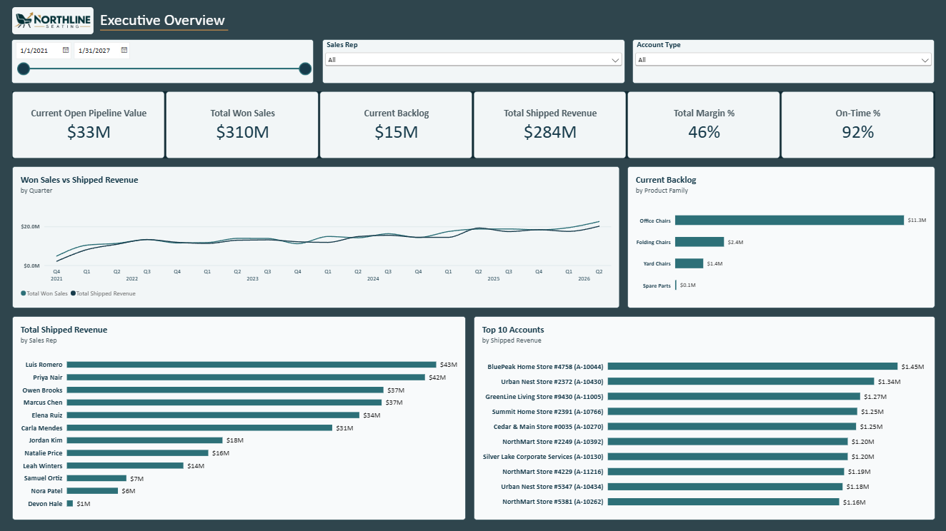
Overview of current pipeline, won sales, backlog, shipped revenue, margin, on-time performance, sales reps, and top accounts.

Sales Pipeline
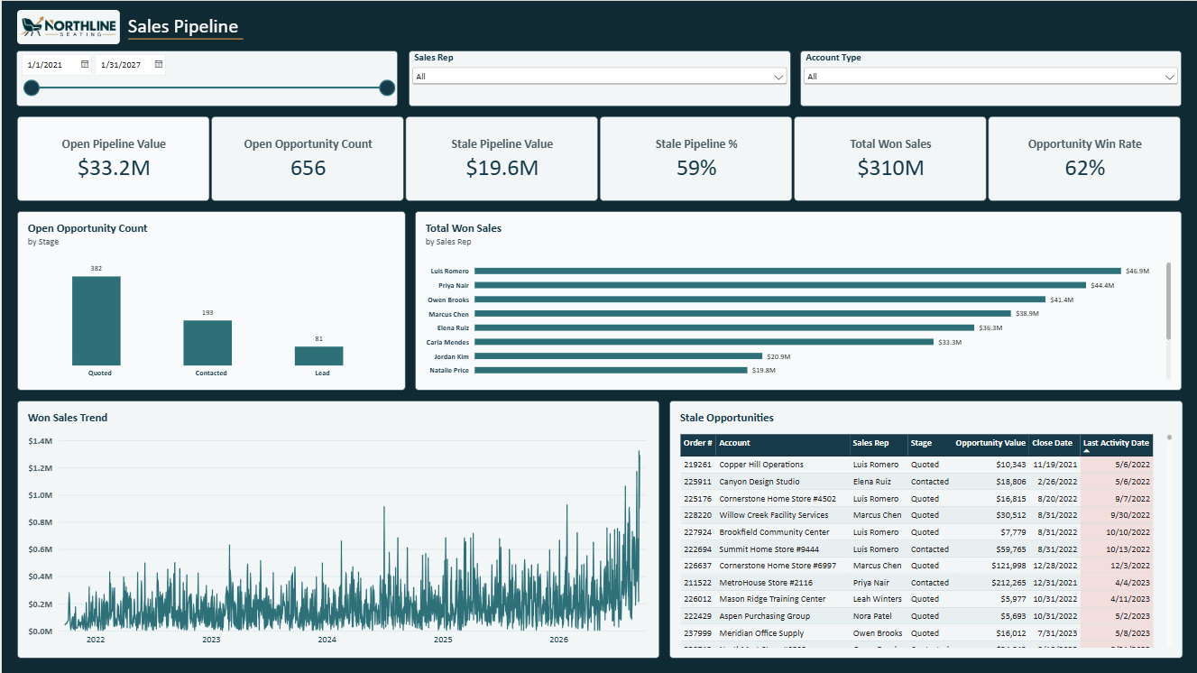
Pipeline and stale opportunity follow up with stage counts, rep performance, won sales trend, and the action queue.

Account Ranking
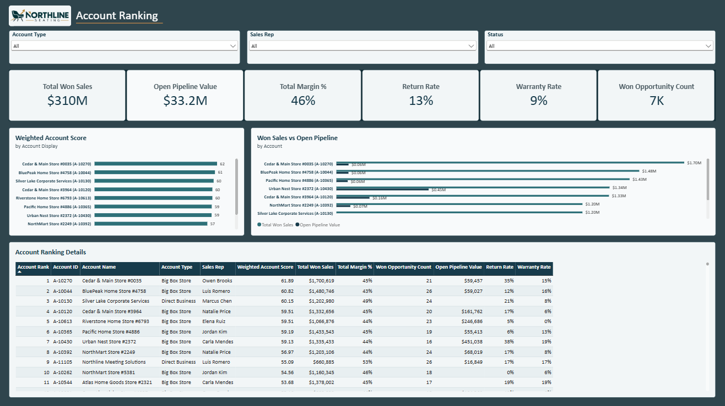
Weighted account ranking built from won value, margin, won orders, pipeline, return rate, and warranty rate.

Product & Margin
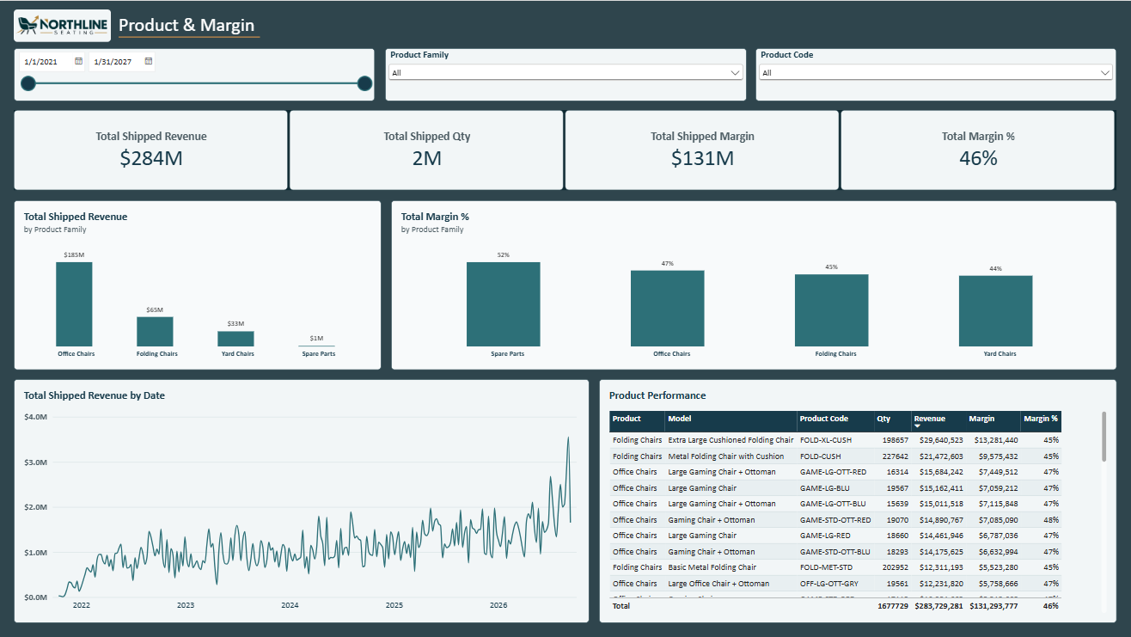
Product family revenue and margin, revenue trend, and detailed product performance in one view.

Delays & Operations
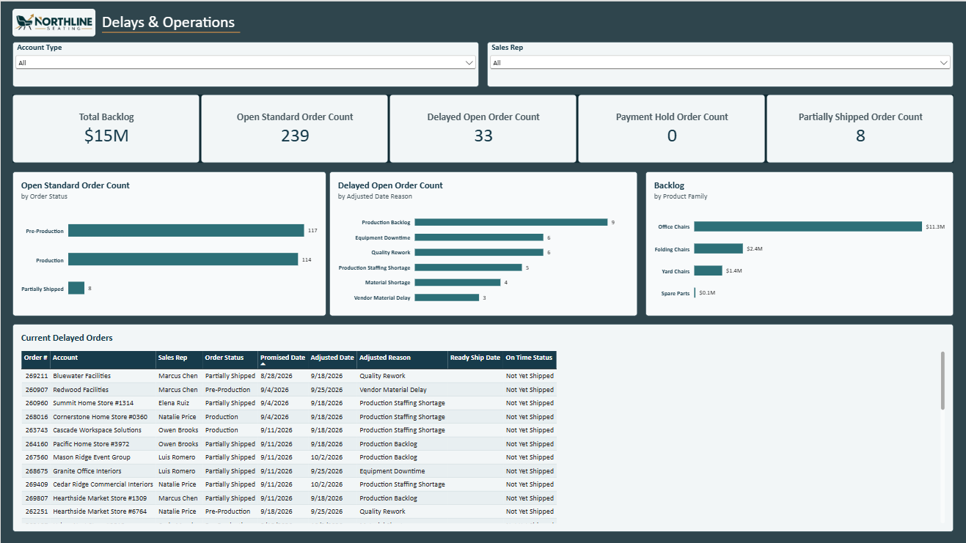
Current work queue for open delayed orders, with backlog, order status, and adjusted date reason context.

Returns & Warranty
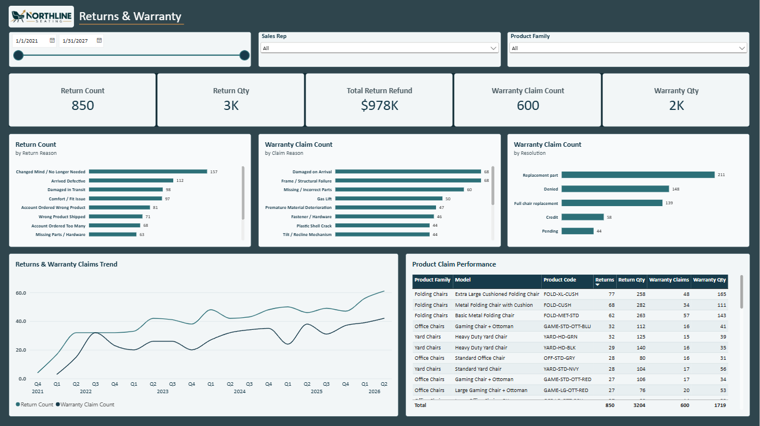
View of return reasons, warranty reasons and resolutions, trends, and product claim performance.

Tools Used
Tool | Use in Project
Excel / Power Query | Source cleanup, data typing, transformations, working audit trail
Python / pandas | QA after cleanup, reconciliation, and relationship validation
SQLite / SQL | Independent QA and business analysis
Power BI / DAX | Data model, measures, drillthrough, report design, final reporting layer
VS Code | Python and SQL development environment

Project Outcome
This project gives me a complete BI workflow I can walk through from raw data to final reporting. The raw and cleaned data are both available, the QA and SQL work can be reviewed, and the Power BI report ties the business rules back to the final metrics and visuals.

